Q. 1) Find all the unique 'Wind Speed' values in the data.

Q. 2) Find the number of times when the 'Weather is exactly Clear'.

Q. 3) Find the number of times when the 'Wind Speed was exactly 4 km/h'.

Q. 4) Find out all the Null Values in the data.

Q. 5) Rename the column name 'Weather' of the dataframe to 'Weather Condition'.

Q. 6) What is the mean 'Visibility' ?

Q. 7) What is the Standard Deviation of 'Pressure' in this data?

Q. 8) What is the Variance of 'Relative Humidity' in this data ?

Q. 9) Find all instances when 'Snow' was recorded.

Q. 10) Find all instances when 'Wind Speed is above 24' and 'Visibility is 25'.

Q. 11) What is the Mean value of each column against each 'Weather Condition ?

Q. 12) What is the Minimum & Maximum value of each column against each 'Weather Condition ?

Q. 13) Show all the Records where Weather Condition is Fog.

Q. 14) Find all instances when 'Weather is Clear' or 'Visibility is above 40'.

Q. 15) Find all instances when :

A. 'Weather is Clear' and 'Relative Humidity is greater than 50'

or

B. 'Visibility is above 40'

Where u can use the below

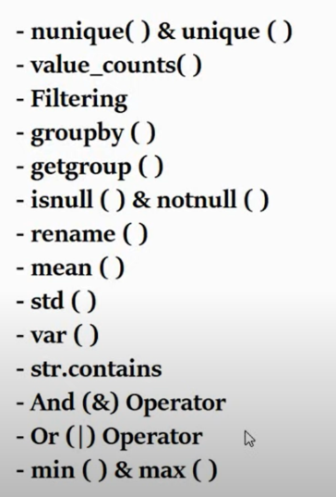

REPORT

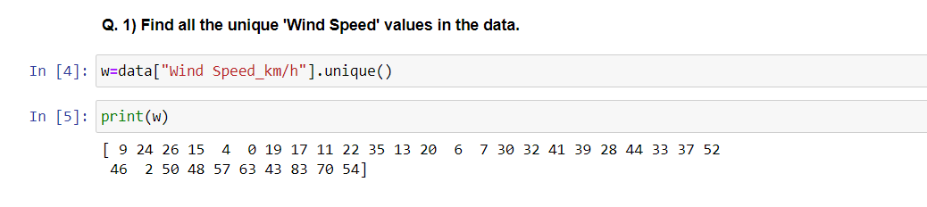

Explanation: These Commands will give you a list of all “UNIQUE” Wind speed values in your dataset.

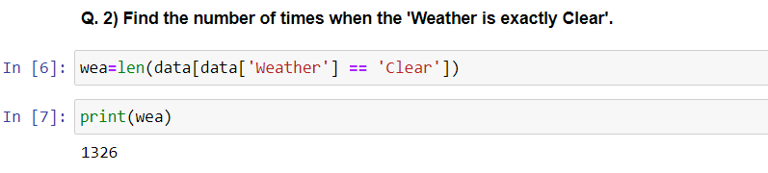

Explanation: These Commands will give you the number of times when the “Weather” is exactly clear.

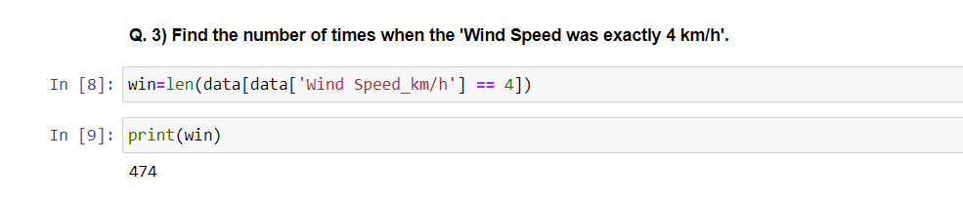

Explanation: This code will count the number of times when the 'wind speed' was exactly 4 km/h in your dataset.

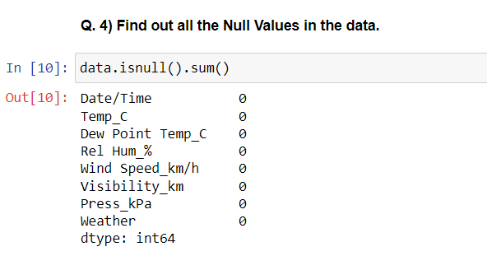

Explanation: 1. To find all the null (missing) values in your dataset, you can use the is null () function. AND

2.This code will display the count of null values in each column of your dataset.

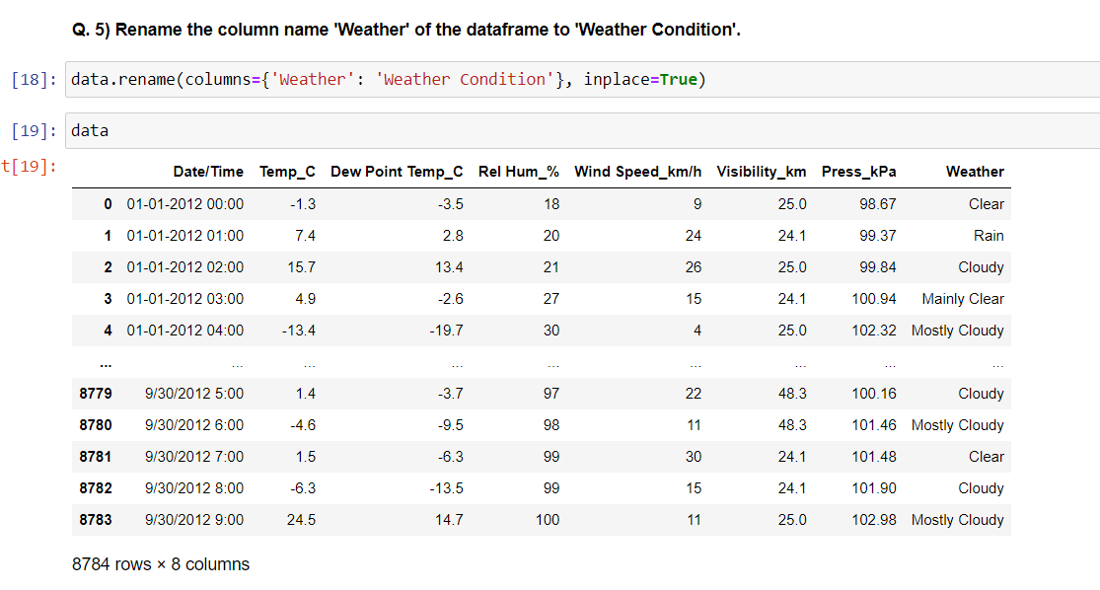

**Explanation:** In the code above, we use the rename method and provide a dictionary to specify the mapping of old column names to new column names. The in place =True argument allows you to modify the Data Frame in place.

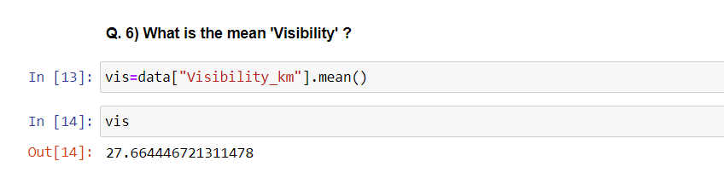

**Explanation:** This code will calculate the mean 'Visibility' from your Data Frame. Using “mean” function.

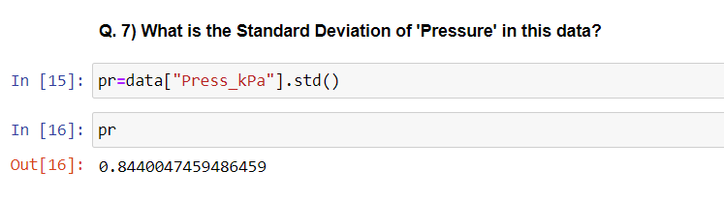

**Explanation:** This code will calculate Standard Deviation of the 'pressure' from your Data Frame. Using “std()” function.

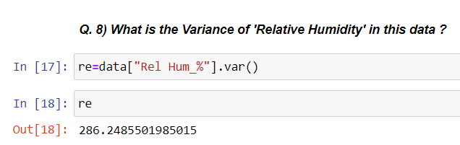

**Explanation:** This code will calculate variance of the 'Realtive Humidity' from your Data Frame. Using “var()” function.

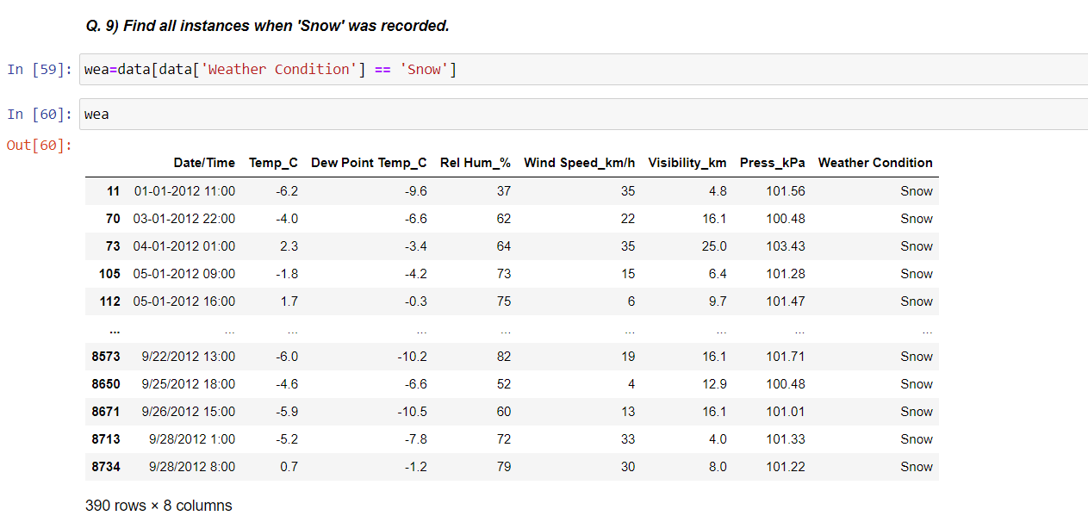

**Explanation:** This code will load your dataset, filter it to include only the rows where 'Weather Condition' is 'Snow', and print those rows to display all instances when 'Snow' was recorded in your data.

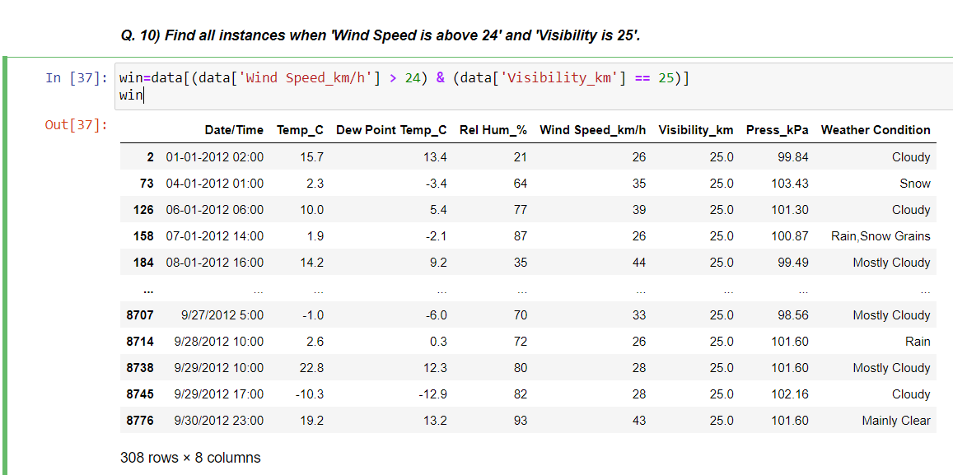

**Explanation:** This code is, filter it to include only the rows where 'Wind Speed' is greater than 24 and 'Visibility' is 25, and then print those rows to display all instances that meet both conditions.

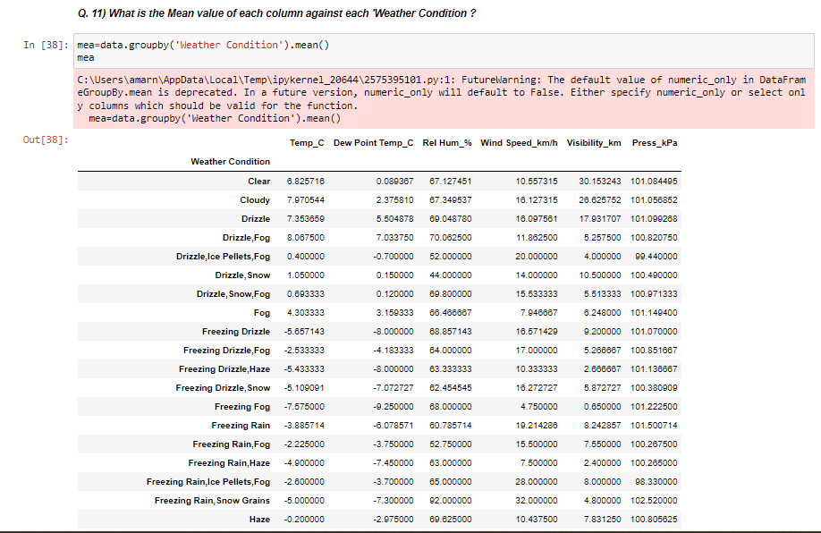

**Explanation:** This code will group your data by the 'Weather Condition' column and then calculate the mean value for each column within each group. It will print a Data Frame with the mean values for each column against each 'Weather Condition '.



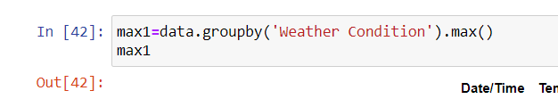

**Explanation:** This code will group your data by the 'Weather Condition' column and then calculate the min, max value for each column within each group. It will print a Data Frame with the min, max values for each column against each 'Weather Condition '.

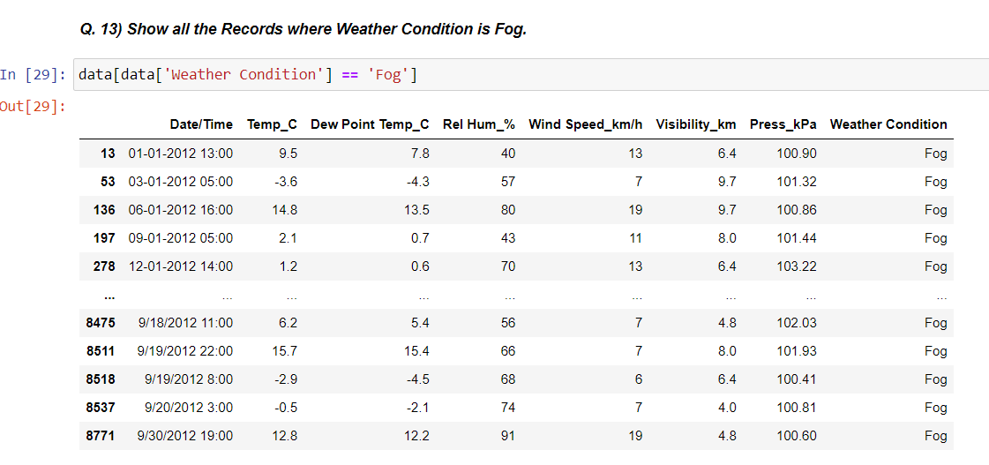

**Explanation:** This code will load your dataset, filter it to include only the rows where 'Weather Condition' is 'Fog', and print those rows to display all instances when 'Fog' was recorded in your data.

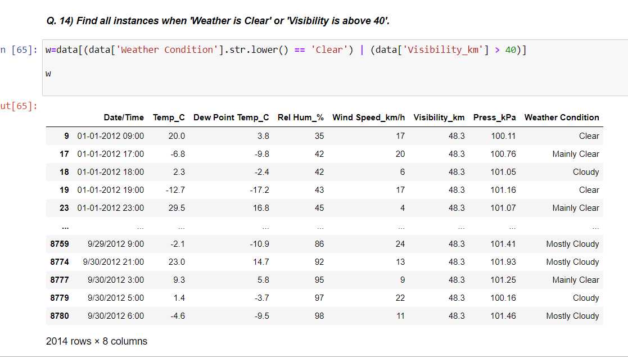

**Explanation:** This code will give you a Data Frame containing all instances where 'Weather Condition' is 'Clear' or 'Visibility_ km ' is greater than 40.

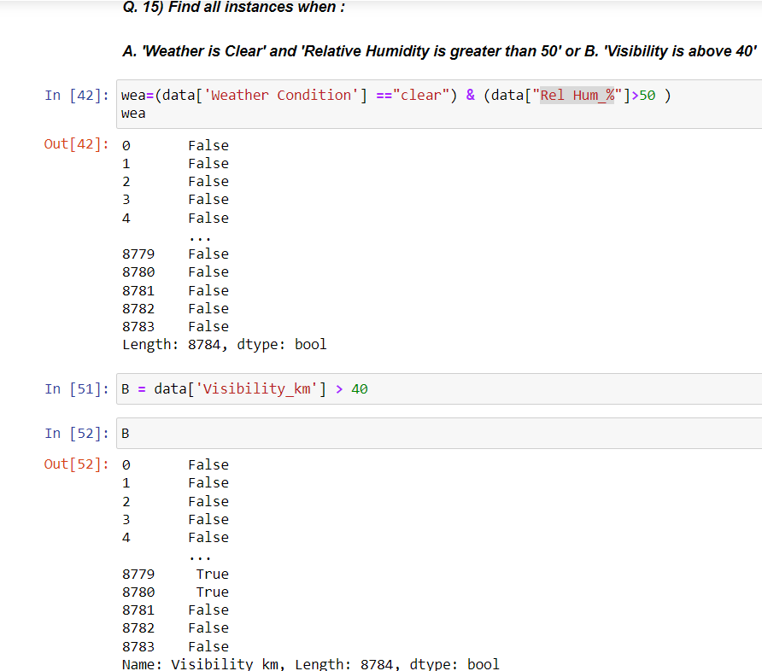

**Explanation:** This code first defines the two conditions wea and B using parentheses. Then, it combines these conditions using the logical OR operator | to get rows that meet either condition wea or condition B. Finally, it prints the resulting Data Frame containing all instances that meet either condition.